CECS 326

Spring 2017

Haney Williams

Project 2

Phanna Chrin

Amanda Pan

**Given Problem:**

Write a parent program and a child program using C/C++ to do the following. The parent program uses a command line argument to generate 4 child processes. The parent program receives two integer numbers A and B and a sleep time T from the command line arguments. The parent displays the two numbers, sleeps for a random time modulo T, then passes these two numbers together with the child number and the sleep time T to the 4 child process. The child program sleeps for a random time modulo T, then performs an arithmetic operation on the two numbers as follows: Child 0 generates S = A+B (addition). Child 1 generates D = A-B (subtraction). Child 2 generates P = A*B (multiplication). Child 3 generates Q = A/B (division). The child program displays the child number, its child PID, and the result of the computation. The sleep time T must be a positive integer no larger than 50. Use a random seed number each time the parent program is run.

**Problem Analysis:**

This project is to master *exec()* and *fork()* functions. The parent process must take 3 arguments. It will have a maximum of T seconds sleeping time and receives the 2 numbers. It then process forks 4 children and passes the 2 numbers to do the addition, subtraction, multiplication, and goes to sleep for a random time of mod T. Each child sleeps for a random time of mod T, receives the 2 numbers from the parent process and does its own function. The sleeping time must be a positive number and not larger than 50. The parent prints out the maximum sleeping time and the 2 numbers. Each child prints out the child number, PID, and the result.

**Program Flowchart:**

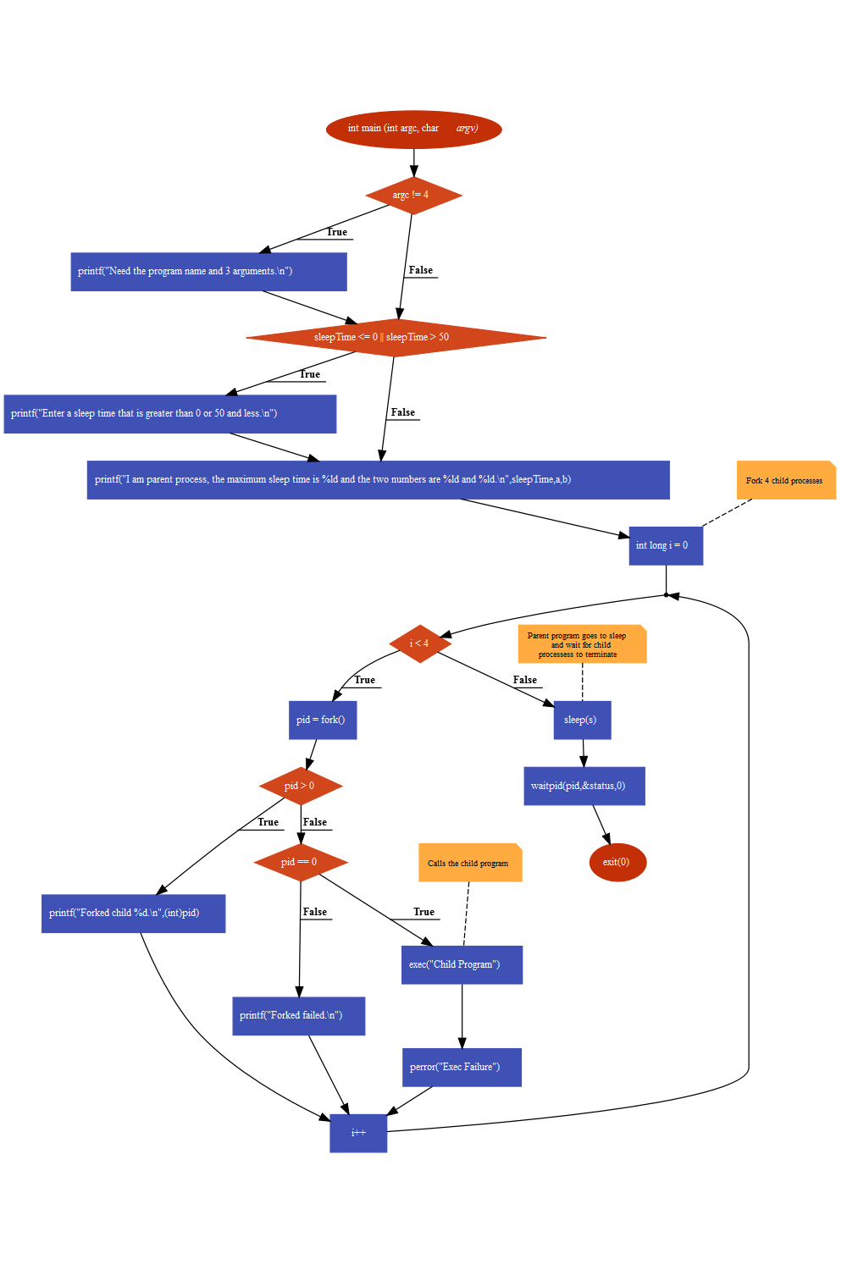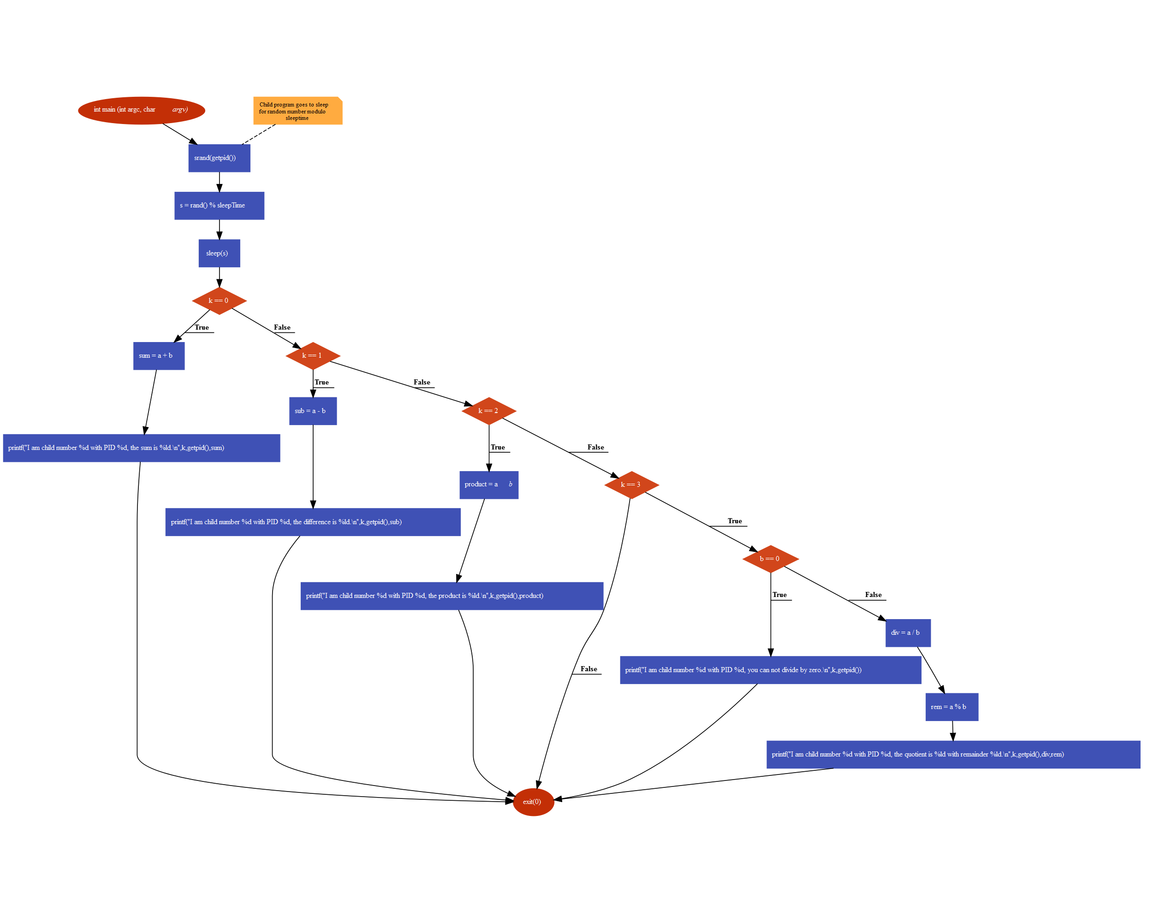

**C Code:**



**Output:**

